

UNIVERSITY OF THE WESTERN CAPE
TUTORIAL 4

AND

MR HEARNS WORKSHEET EXERCISE

WEEK 4 (14 – 18 SEP)

INFORMATION SYSTEMS
244

Student Surname , Name : Batyi, Mbasa
Student Number : 4540469
Group : 01

p

Tutorial Answers
1 | PL/SQL code
SET SERVEROUTPUT ON;
ACCEPT emp_id_input NUMBER PROMPT 'Enter the employee id: ';

DECLARE
iEmp_id HR.employees.employee_id%TYPE := &emp_id_input;
sFirst_name HR.employees.first_name%TYPE;
sLast_name HR.employees.last_name%TYPE;
sJob_id HR.employees.job_id%TYPE;
sRow VARCHAR2(200);
sBorder VARCHAR2(200);

BEGIN
SELECT first_name,
last_name,
job_id
INTO sFirst_name,
sLast_name,
sJob_id
FROM HR.employees
WHERE employee_id = iEmp_id;

sRow := '| ' || sLast_name || ' | ' || sFirst_name || ' | ' || sJob_id || ' |';

sBorder := '+';
FOR i IN 1 .. LENGTH(sRow) - 2
LOOP
sBorder := sBorder || '-';
END LOOP;
sBorder := sBorder || '+';

FOR i IN 1 .. LENGTH(sBorder)
LOOP
DBMS_OUTPUT.PUT(SUBSTR(sBorder, i, 1));
END LOOP;

DBMS_OUTPUT.NEW_LINE;
DBMS_OUTPUT.PUT_LINE(sRow);

FOR i IN 1 .. LENGTH(sBorder)
LOOP
DBMS_OUTPUT.PUT(SUBSTR(sBorder, i, 1));
END LOOP;
DBMS_OUTPUT.NEW_LINE;

EXCEPTION
WHEN NO_DATA_FOUND THEN
DBMS_OUTPUT.PUT_LINE('No employee found with ID ' || iEmp_id);

END;
/

Output
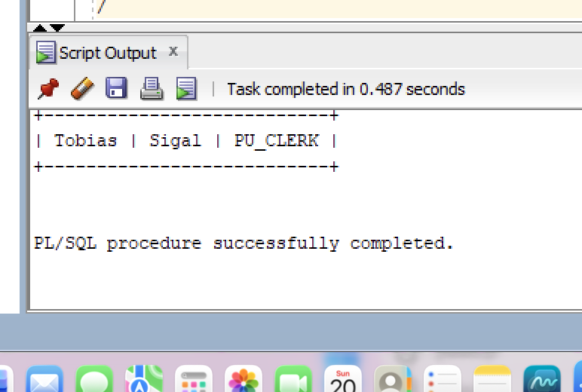

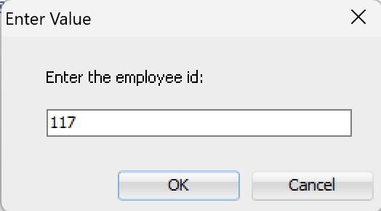

2 | PL/SQL code
SET SERVEROUTPUT ON;
DECLARE
CURSOR emp_cursor IS
SELECT e.employee_id,
e.first_name,
e.last_name,
e.salary,
j.job_title
FROM HR.employees e
JOIN HR.jobs j ON e.job_id = j.job_id
WHERE e.department_id = 60
ORDER BY e.salary DESC;

iEmployee_id HR.employees.employee_id%TYPE;
sFirst_name HR.employees.first_name%TYPE;
sLast_name HR.employees.last_name%TYPE;
iSalary HR.employees.salary%TYPE;
sJob_title HR.jobs.job_title%TYPE;

iCount NUMBER := 0;

BEGIN
OPEN emp_cursor;
LOOP
FETCH emp_cursor
INTO iEmployee_id,
sFirst_name,
sLast_name,
iSalary,
sJob_title;
EXIT WHEN emp_cursor%NOTFOUND;

iCount := iCount + 1;

IF iSalary < 5000 THEN
DBMS_OUTPUT.PUT_LINE(sFirst_name || ' ' || sLast_name ||
' works as ' || sJob_title || ' with salary ' || iSalary ||
' (Standard Earner)');
ELSE
DBMS_OUTPUT.PUT_LINE(sFirst_name || ' ' || sLast_name ||
' works as ' || sJob_title || ' with salary ' || iSalary ||
' (Higher Earner)');
END IF;
END LOOP;
CLOSE emp_cursor;
END;
/

Output
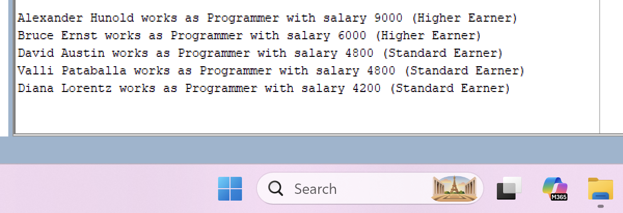

3 | PL/SQL code
SET SERVEROUTPUT ON;

CREATE OR REPLACE PROCEDURE dept_salary_report (proc_dept_id IN HR.departments.department_id%TYPE)
IS
sDept_name HR.departments.department_name%TYPE;
nAvg_salary NUMBER;
sBorder VARCHAR2(60) := RPAD('-', 60, '-');

CURSOR emp_cursor IS
SELECT first_name,
last_name,
job_id,
salary
FROM HR.employees
WHERE department_id = proc_dept_id
ORDER BY salary DESC, employee_id;

sTag VARCHAR2(20);
BEGIN
SELECT department_name
INTO sDept_name
FROM HR.departments
WHERE department_id = proc_dept_id;

SELECT AVG(salary)
INTO nAvg_salary
FROM HR.employees
WHERE department_id = proc_dept_id;

DBMS_OUTPUT.PUT_LINE('Department: ' || sDept_name);
DBMS_OUTPUT.PUT_LINE('Average Salary: ' ||TO_CHAR(nAvg_salary,
'FML999G999G990D00',
'NLS_NUMERIC_CHARACTERS=''.,
'' NLS_CURRENCY=''R'''));
DBMS_OUTPUT.PUT_LINE(sBorder);

FOR emp_rec IN emp_cursor
LOOP
IF emp_rec.salary > nAvg_salary THEN
sTag := '(Above Avg)';
ELSE
sTag := '(Below Avg)';
END IF;

DBMS_OUTPUT.PUT_LINE(
RPAD(emp_rec.first_name || ' ' || emp_rec.last_name, 20) ||
RPAD(emp_rec.job_id, 12) ||
LPAD(TO_CHAR( emp_rec.salary,
'FML999G999G990',
'NLS_NUMERIC_CHARACTERS=''.,
'' NLS_CURRENCY=''R'''), 8) ||' ' || sTag);
END LOOP;

DBMS_OUTPUT.PUT_LINE(sBorder);

EXCEPTION
WHEN NO_DATA_FOUND THEN
DBMS_OUTPUT.PUT_LINE('No department found with ID ' || proc_dept_id || '.');

END dept_salary_report;
/

BEGIN
dept_salary_report(60);
END;
/

 | Output
 | 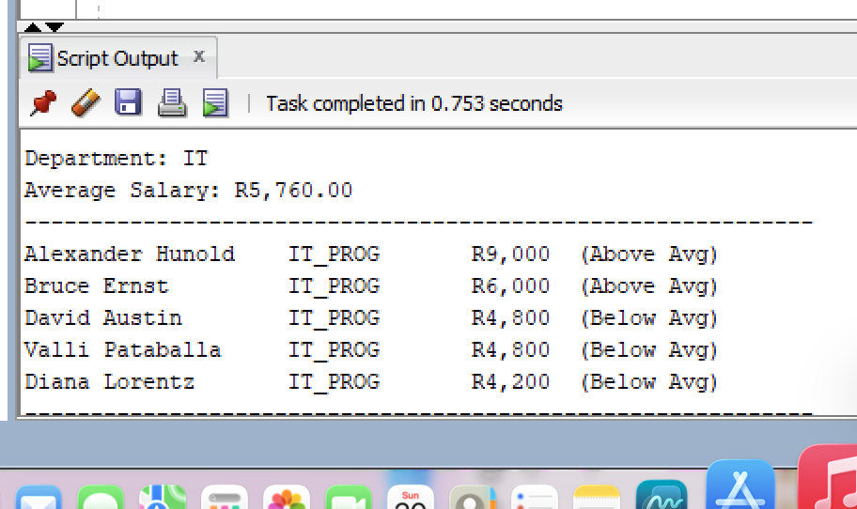

MR HEARN’S WORKSHEET EXERCISE ANSWERS
1 | PL/SQL code : Exercise 1
SET SERVEROUTPUT ON;
DECLARE
iNumber_of_records NUMBER := &number_of_records;
sStart_id HR.employees.employee_id%TYPE := &id;
sCurrent_id HR.employees.employee_id%TYPE;
sLast_name HR.employees.last_name%TYPE;

BEGIN
DBMS_OUTPUT.PUT_LINE(iNumber_of_records || ' records requested.');
DBMS_OUTPUT.PUT_LINE('');

FOR i IN 0 .. iNumber_of_records - 1
LOOP
sCurrent_id := sStart_id + i;

SELECT last_name
INTO sLast_name
FROM HR.employees
WHERE employee_id = sCurrent_id;

DBMS_OUTPUT.PUT_LINE(sCurrent_id || ' ' || sLast_name);
END LOOP;

EXCEPTION
WHEN NO_DATA_FOUND THEN
DBMS_OUTPUT.PUT_LINE('No data was found from ID ' || sCurrent_id || '.');
END;
/

Output
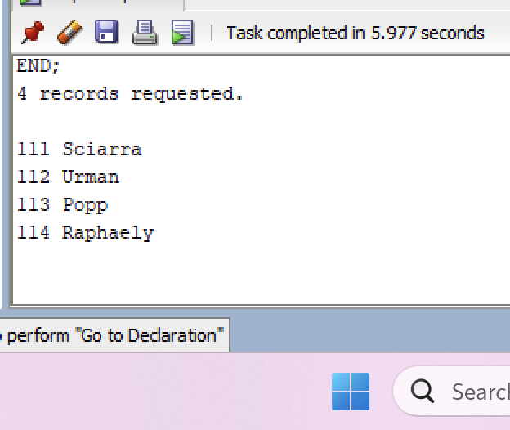

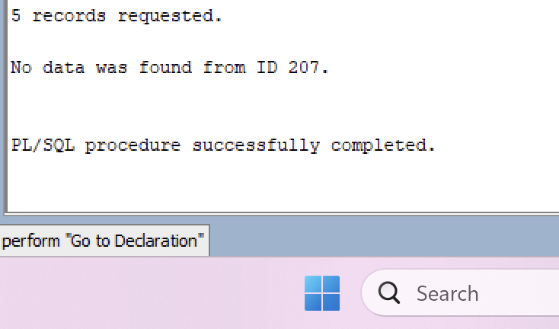

2 | PL/SQL code : Exercise 2
SET SERVEROUTPUT ON;
DECLARE
CURSOR emp_cursor IS
SELECT e.employee_id,
e.first_name,
e.last_name,
e.salary,
j.job_title
FROM HR.employees e
JOIN HR.jobs j ON e.job_id = j.job_id
WHERE e.department_id = 60
ORDER BY e.salary DESC;

iEmployee_id HR.employees.employee_id%TYPE;
sFirst_name HR.employees.first_name%TYPE;
sLast_name HR.employees.last_name%TYPE;
iSalary HR.employees.salary%TYPE;
sJob_title HR.jobs.job_title%TYPE;

iCount NUMBER := 0;

BEGIN
OPEN emp_cursor;
LOOP
FETCH emp_cursor
INTO iEmployee_id,
sFirst_name,
sLast_name,
iSalary,
sJob_title;
EXIT WHEN emp_cursor%NOTFOUND;

iCount := iCount + 1;

IF iSalary < 5000 THEN
DBMS_OUTPUT.PUT_LINE(sFirst_name || ' ' || sLast_name ||
' works as ' || sJob_title || ' with salary ' || iSalary ||
' (Standard Earner)');
ELSE
DBMS_OUTPUT.PUT_LINE(sFirst_name || ' ' || sLast_name ||
' works as ' || sJob_title || ' with salary ' || iSalary ||
' (Higher Earner)');
END IF;
END LOOP;
CLOSE emp_cursor;
END;
/

Output

